Continuous Integration & Continuous Deployment Lab

EXPERIMENT – 14 (Docker)

**Name : Prakhhar Tandon**

**Roll No : R171218115**

1. Inside the Ubuntu virtual machine running using vagrant, firstly checking if machine is compatible with docker, then adding repository for docker

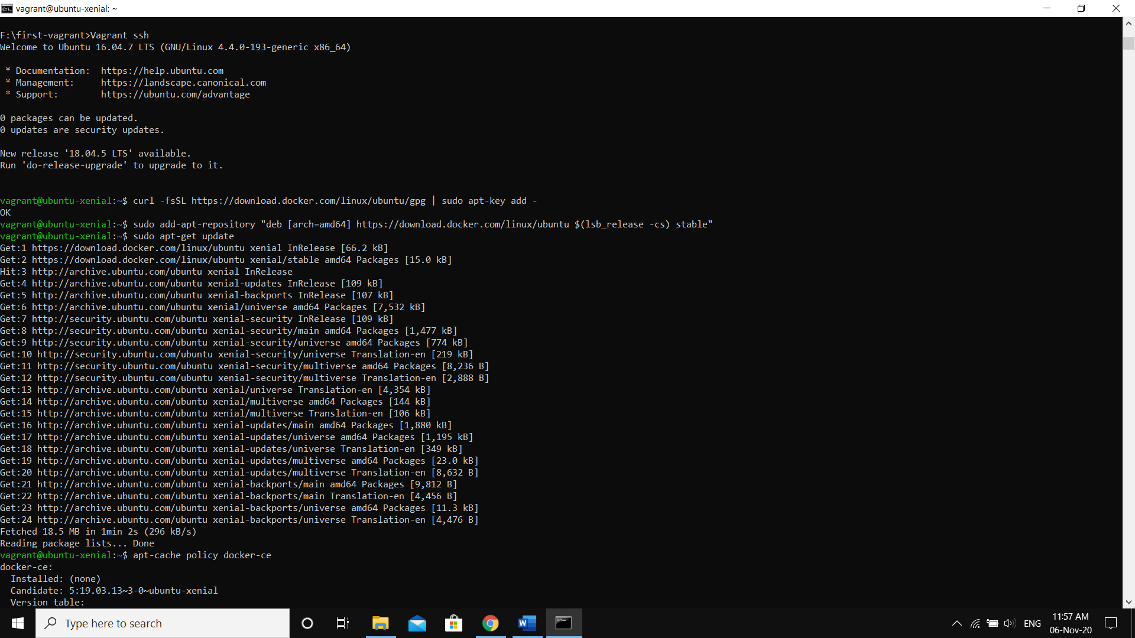

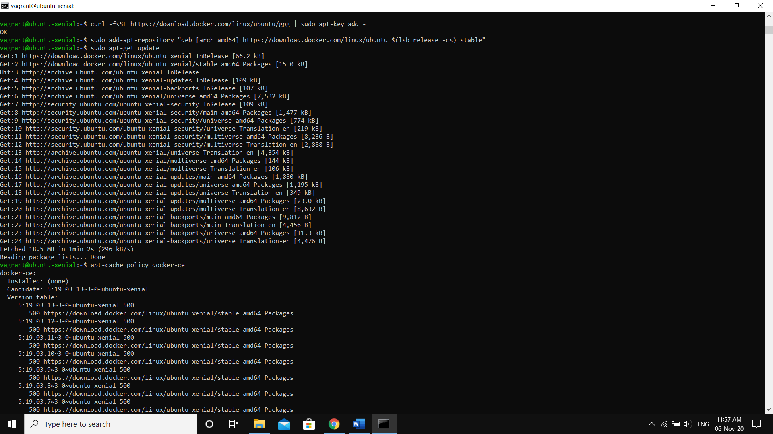

1. Installing Docker

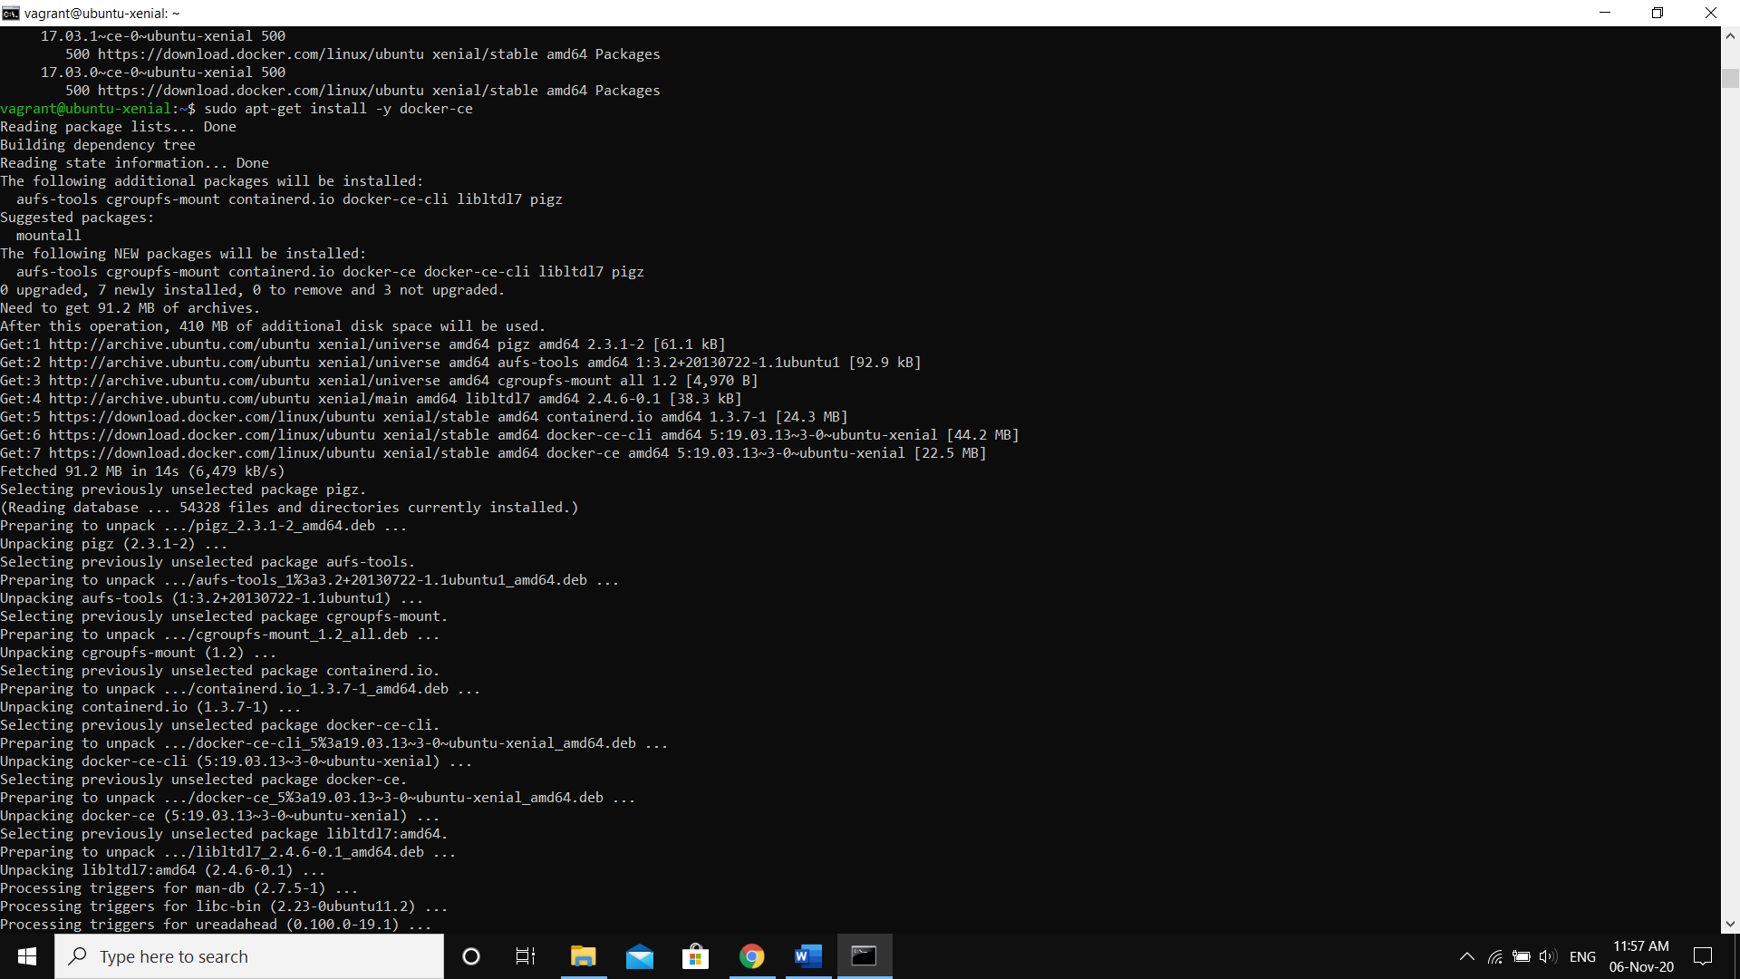

1. Checking if docker is running or not

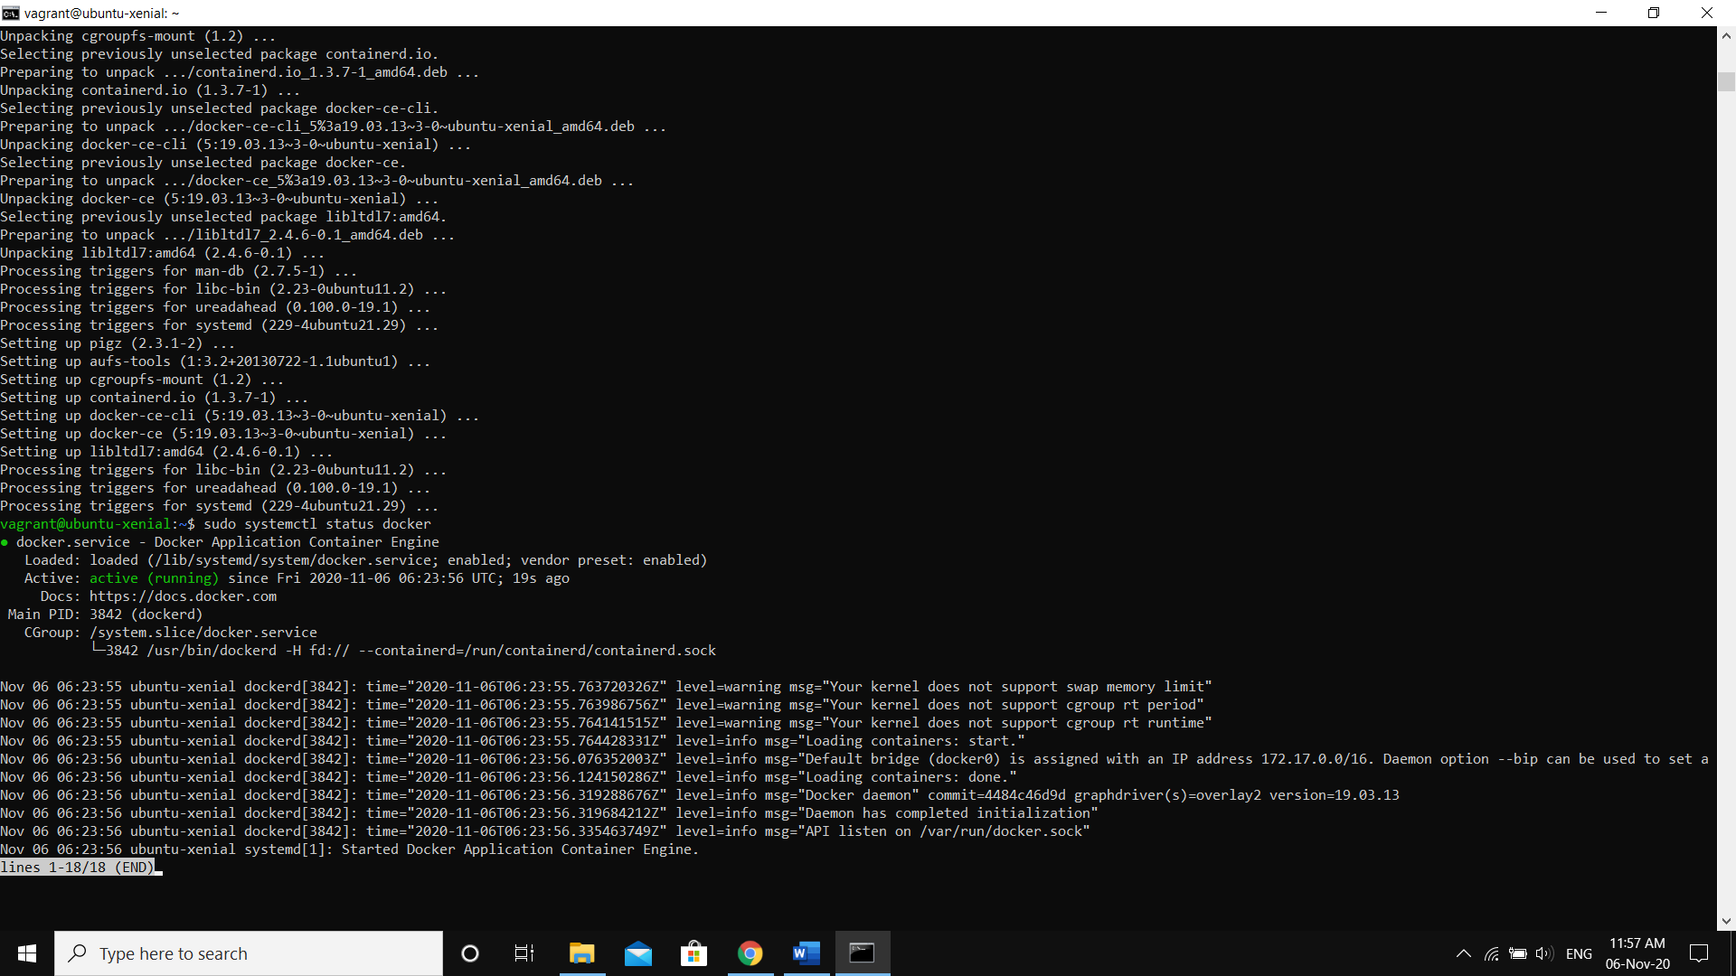

1. Running an ubuntu container inside docker which is running on an ubuntu virtual machine using vagrant on a windows host machine

